

**DEPARTMENT: ELECTRICAL AND ELECTRONICS ENGINEERING**

**OPTION: ELECTRICAL TECHNOLOGY (ELT)**

**MODULE NAME: Programmable Ics Workshop**

**ACADEMIC YEAR: 2021-2022**

**Level: III**

**SEMESTER: I**

**NAME OF MINI PROJECT: TURNING ON A BULB LAMP USING**

**BLUETOOTH MODULE**

**Prepared by:**

* **MBONINYIBUKA Samson**
* **NSHIMYIMANA Valens**

**NAME OF PROJECT: TURNING ON A BULB LAMP USING**

**BLUETOOTH MODULE**

**Abstract**

There is many way used in wireless technology such as Bluetooth, in this project we use Bluetooth wireless technology and a smart phone application to turn on a bulb lamp. The relay is used to connect these design and implemented and also used to connect these appliances to the input/ output ports of the board.The use of wireless Bluetooth connection in control board enables a simplified way to system installation. In briefly the use of Bluetooth and Arduino is presented. Android technique in smart phone is also presented. These components are the main parts of the proposed mini project. This project is a low cost and using a new technology and devices for this application.The system has been built and running successfully. [1]

Keywords: Home automation; Smartphone; Arduino; Bluetooth; Home appliances (bulb).

**Problem statement**

Here this project has the goals of establish a wireless protocol for switching a light bulb ON and OFF using a simple app on a smart phone. Using a wireless become a solution in industries or home application Increases mobility eliminates expensive and maintenance-heavy transmission media such as flexible cables, swivels, etc. Overcoming large and problematic zones has to achieve fast and efficient installation and commissioning. Ensure personnel safety in hazardous areas (for instance, when needing to climb in a crane) by offering a control possibility from a further distance than can be the case with a cable. [2]

**Block diagram**

**Arduino Device**

**Bluetooth Module**

**(HC-05)**

Android Device

(Via Bluetooth application)

**1 Channel Relay Module**

# C:\Users\Ethmy\Desktop\Screenshot 2022-04-19 205348.png C:\Users\Ethmy\Desktop\Screenshot 2022-04-19 205348.png C:\Users\Ethmy\Desktop\Screenshot 2022-04-19 205348.png C:\Users\Ethmy\Desktop\Screenshot 2022-04-19 205348.png

**Description**

In this project, there are four main components used: Android smartphone Bluetooth application, Bluetooth transceiver, Arduino device, and 1 Channel Relay module.

Here the Android app sends the Serial data to the connected Bluetooth Module HC-05 by clicking ON button. The Bluetooth devices receive the data from the app and send it through TX pin of Bluetooth module to RX pin of Arduino. The Arduino device read the input data and process it according to program uploaded inside it and generate the output to 1 Chanel Relay Module.

When the Bluetooth application’s button turns ON, It sets the bulb ON, and when the Bluetooth application’s button turns OFF, it sets the bulb OFF.

**Circuit diagram drawn in fritzing**

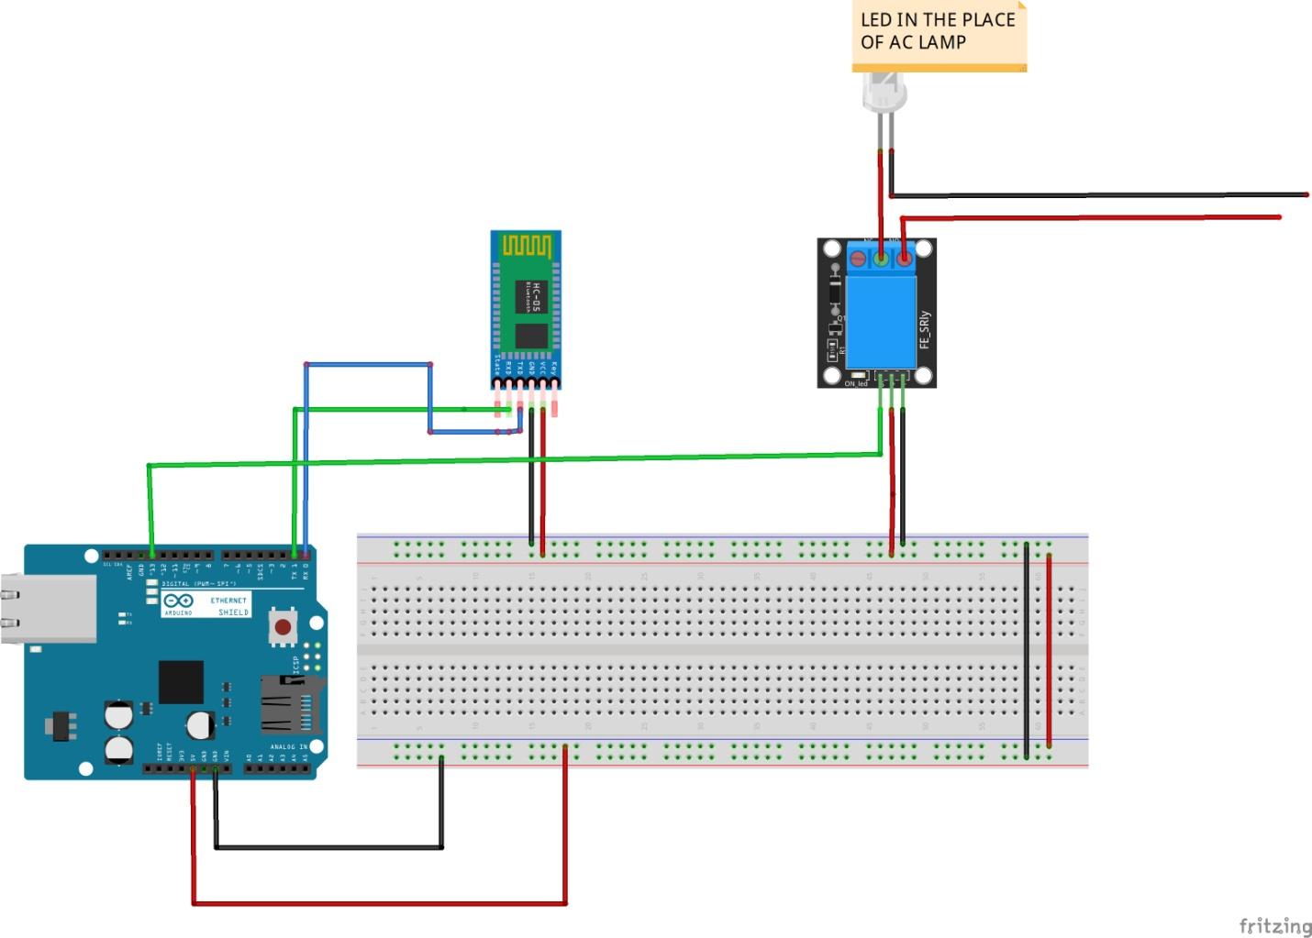

**Arduino IDE Developed Source Codes**

char Incoming_value = 0;

void setup() {

Serial.begin(9600);

pinMode(13,OUTPUT);

}

void loop() {

if (Serial.available() > 0)

{

Incoming_value = Serial.read();

Serial.print(Incoming_value);

if (Incoming_value == '1')

digitalWrite(13,HIGH);

else if(Incoming_value == '0')

digitalWrite(13,LOW);

}

}

**SIMURATION IN PROTEUS**

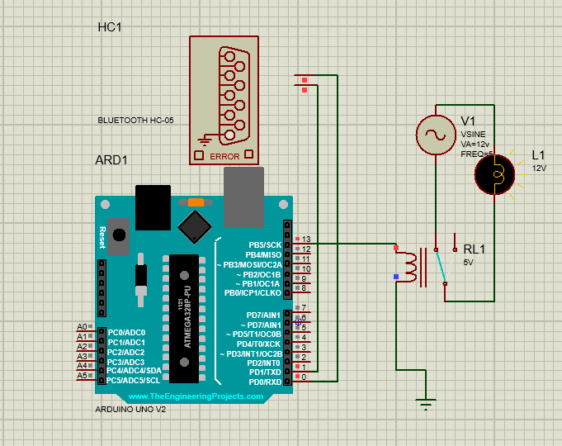

**References**

[1] A. Kareem and K. Abdul, “Bluetooth Based Smart Home Automation System using Arduino UNO Microcontroller,” vol. 72, no. 27, 2017.

[2] “Bluetooth module Home Automation Industry-Based Applications Components :”